Bidirectional LSTM Approach to Image Captioning with Scene Features

Davis Agughalamª, Pramod Pathak^{b}, Paul Stynes*^{c}
^{abc} National College of Ireland, D01 K6W2, Ireland

Abstract
Image captioning involves generating a sentence that describes an image. More recently, it has been driven by encoder-decoder approaches where the encoder such as convolutional neural network (CNN) can extract the visual features of an image. The extracted visual features are passed to a decoder such as a long short-term memory (LSTM) network in order to generate a sentence that describes the image. One major challenge with this approach is to precisely include the scene of an image in the generated sentences. To resolve this challenge, visual scene features have been used with unidirectional LSTM decoders. However, for long sentences, this limits the precision of the generated text. This research proposes a novel approach to generate sentences using visual scene information with a bidirectional LSTM decoder. The encoder is based on Inception v3 to extract the object features and Places365 to extract the scene features. The decoder uses a bidirectional LSTM to generate a sentence. The encoder-decoder model is trained using the Flickr8k dataset. Results show improved performance for generating longer sentences with a 9% increase in BLEU-3 and a 12% increase in BLEU-4 scores compared to compared to other encoder-decoder methods that are limited to only using global image features. Visually impaired people that use screen readers would benefit from this research as they would get an enhanced description of an image that includes the background scene thereby creating a wholesome picture in the mind of the reader.

Keywords: Image captioning, Convolutional neural network, Long short-term memory network

INTRODUCTION
Image captioning is used in screen readers to generate a sentence that describes an image for the visually impaired. One of the challenges with image captioning is to precisely include the scene of an image in the generated sentences in order to create a more complete description for a reader.
Approaches to image captioning have evolved from template-based and retrieval-based methods to encoder decoder approaches^{[1]}.In template-based methods, objects detected in an image are filled into a static template to form a sentence. Usually the sentences are not semantically coherent with the image^{[2]}.In retrieval-based methods, sentences describing similar images are retrieved from a training dataset and used as the sentence that describes the image under scrutiny. This approach requires a large training dataset and is time consuming^{[2]}.
In encoder-decoder approaches, the encoder extracts the visual features of an image and the decoder translates the features in order to generate a sentence that describes the image. The encoder-decoder approach demonstrates superior performance over template-based and retrieval-based methods^{[2],[3]}. Typically, a convolutional neural network (CNN) is used to implement the encoder and a recurrent neural network (RNN) is used to implement the decoder. Current research demonstrates that CNN is suited for image processing and RNN is better suited to machine translation tasks^{[4]}. Image object features extracted using the CNN lack the ability to precisely portray the scene of an image^{[5]}. Zhang et al^{[5]} proposed the need for extra features such as semantic element embeddings, part of speech (POS) tags and object descriptors to augment the high-level features extracted using CNNs to better represent every aspect of the image especially in complex scenes. RNN models are prone to becoming unstable where the model is unable to learn from the training data due to the exploding gradient problem. This has led to the adoption of the long short-term memory (LSTM) variant for image captioning purposes^{[3],[6]}. Peng et al.^{[7]} investigated visual scene features to improve the semantic

*Paul.Stynes@ncirl.ie; phone +353 1 4498613; www.ncirl.ie
correctness of generated sentences with unidirectional LSTMs. Unidirectional LSTMs retain past information for training and prediction sequences while bidirectional LSTMs leverage past and future information in the sequence to improving performance for longer word sequences^{[4]}. Visual features that identify the image scene have not been investigated with bidirectional LSTM decoders.
The aim of this research is to investigate to what extent can a combination of visual scene features and past and future information in the word sequence improves the semantic richness of automatically generated image descriptions. The past and future information in the word sequence is implemented using a bidirectional LSTM.
The major contribution of this research is a novel approach that combines visual scene features and bidirectional LSTMs to generate semantically correct image captions.
This paper discusses related work that focuses on encoder-decoder approaches to image captioning in Section 2. Section 3 describes the research methodology used in this research. Section 4 presents and discusses research results while section 5 presents a conclusion.

Related Work
Image captioning involves automatically generating appropriate sentence descriptions for images^{[3]}. Initially, retrieval and template-based approaches were mostly employed for image captioning tasks. Current approaches to image captioning uses encoder-decoder deep neural network^{[1]} with a focus on CNN-LSTM^{[3],[6],[8],[9]} and CNN-Bidirectional LSTM^{[10][11]} architectures. Enhancements to this architecture have been made using text features such semantic element embeddings and POS tags ^{[5],[12]} and the attention mechanism ^{[13],[14],[15]}.
In a CNN-LSTM architecture, the images are processed for features using a pretrained CNN^{[3],[6],[8],[9]}. These features are passed into the LSTM decoder for sentence generation. The LSTM unit ensures better performance than a regular RNN due to its ability to recall previous input data while obtaining new input. This makes it a better option for sequence to sequence and vector to sequence translations such as this. Their approach produced better results than template-based, and retrieval approaches. However, only global image features were employed and information from the text corpus was largely ignored. They also adopted Unidirectional LSTMs, however these are incapable of incorporating future inputs in the sentence generation sequence^{[4]}.
To resolve this challenge, bidirectional LSTMs have been employed as part of a CNN-BiLSTM architecture^{[10],[11]}. CNN-BiLSTM takes advantage of both past and future input feature in the sequence during word predictions to improve the semantic correctness of the generated sentences especially for longer sequences^{[4]}. Wang et al.^{[11]} extracted the image features with a pretrained CNN before passing the features to a deep Bi-LSTM architecture for word translation. Results demonstrate that the Bi-LSTM architecture improved the generation of longer word sequences expressed in higher BLEU scores. Similar research conducted by^{[10]} using a bidirectional LSTM architecture in a dense semantic embedding network (DSEN) for image captioning demonstrates similar results to Wang et al.^{[11]}. Xiao et al.^{[10]} also used different architectures as the encoder namely ResNet and VGG16 pretrained models on DSEN. Results also showed better BLEU scores when using a Bi-LSTM decoder for longer word sequences.
Zhang et al.^{[5]} extracted semantic information from the text corpus as part of the input features. They argued that only visual features extracted with a CNN lack the ability to present scene complexity in the generated text. They employed semantic element information extracted from the text corpus such as part of speech (POS) tags to improve the generation of image descriptions. He et al.^{[12]} conducted similar research using POS tags as part of the input features in the LSTM. Their results illustrated the advantages of leveraging information extracted from the text data to improve the generated captions as their approaches produced more semantically correct captions due to the use of information from text and image data modes.
Using the entire global image features from the encoder in the decoder during model training is a recurring theme amongst the works reviewed above. This causes a waste of resources as most of the image features are not relevant during learning of particular words in the corpus during training and this negatively affects the results^{[1]}. Alternative approaches using the attention mechanism as part of the encoder-decoder approach have been adopted to solve this problem. Attention enhances the performance of deep neural networks for particular tasks as it amplifies relevant information in the data required for completing said tasks during model training. It mimics the human visual attention system as the brain selectively filters and amplifies information relevant to completing certain tasks for humans^{[16]}. For generating sentence descriptions for images, it is adapted to identify only image features relevant to generating words at each time step of the LSTM word generation sequence.
Dang et al.^{[13]} explored the importance of the attention mechanism in their work using two pretrained CNNs for multi-feature learning. They compared different architectures to test the effect of the attention mechanism. The results indicated that the attention mechanism improved performance significantly as the architecture with the attention layer performed better than the one without in terms of evaluation metrics. Similar research by^{[14]} using the attention mechanism in an encoder-decoder architecture further demonstrated its advantages. Xiao et al.^{[15]} extended the attention mechanism using a double LSTM adaptive attention mechanism. This extension improved the visual attention mechanism as it used a visual sentinel to choose the time step and location to pay attention during word generation. The research conducted by the above authors outline the importance of either visual or textual attention for image captioning as it also helps minimize the modality gap between the text and image features and selects relevant image regions during word prediction.
Two approaches mostly applied for inference in neural machine language tasks are the greedy and beam search approach^{[3]}. For the greedy search approach, the word with the highest softmax probability is chosen at each word prediction step while the beam search method considers more probabilities using a pre-set beam length. A cumulative probability for all the likely words is obtained and the words with the highest probabilities are selected as inference results. The greedy approach performs better than the beam search for inference purposes hence it is the adopted approach in this research. As image captioning varies from other traditional machine learning problems, common metrics such as accuracy and precision are not sufficient to evaluate generated sentences. Specialized evaluation metrics such as the Bilingual evaluation understudy (BLEU) and recall-oriented understudy for gisting evaluation (ROUGE) have been developed and have served as benchmarks for evaluating image captioning results^{[6][17]}. The BLEU is a precision backed metric that compares individual words of the generated sentences with words in the reference text and provides scores depending on the average number of matches. The BLEU metric is limited as it does not evaluate long sentences efficiently^{[17]} and offers no sense of semantic understanding thus other metrics such as the ROUGE were developed. The ROUGE system matches word pairs, n-grams and sequences from the generated text to matches in the reference corpus and returns values based on the number of co-occurrences. The ROUGE-L variant of the ROUGE metrics have been mostly used to evaluate image captioning and returns scores based on the longest common sequence of words between the generated and reference text corpus^{[2]}.
In conclusion, it is seen that semantic embeddings such as POS tags, text cues, word tetrads, topics, bidirectional LSTM architectures and the attention mechanism have been employed to enhance the semantic richness of automatically generated image captions in encoder-decoder approaches^{[5],[11]}. However, visual embeddings have largely been underutilized. Peng et al.^{[7]} investigated the potential impact of image scene features as visual embeddings to improve semantic content of the generated captions but their work was limited as they used unidirectional LSTMs which are incapable of taking future information from the text sequences into consideration during the word translation sequence and do not perform well for longer text sequences. Aiming to address this gap, this work investigates a novel image captioning approach leveraging deep image scene information as visual embeddings to enhance the semantic quality of the generated sentence descriptions while adopting bidirectional LSTMs to harness both past and future information during word predictions and consequently improve the overall performance and there does not appear to be any work that has adopted this combined approach for image captioning.

Research Methodology
The research methodology from data collection and data processing to feature extraction and modelling is illustrated in Figure . In data collection, the Flickr8k dataset^{[18]} contains 8000 images of human and animal activities with each image having five text captions that describe the image as shown in Figure 2.
In data processing, the steps are focused on image and text processing. For image processing, the images are loaded into an array and compressed. They are further normalized to fit the input shape of the pretrained Inception v3 and Places365 VGG16 for global object and deep scene image features respectively. For the text, the data is converted to lower cases to avoid increasing vocabulary for similar words with different capitalizations. Punctuations alongside numerical data are also removed from the text. Sequence start and end indicators are added to the cleaned sentences before they are tokenized.
In feature extraction, the steps are focused on image and text feature extraction. For image feature extraction, global image features are extracted with Inception v3 and scene image features are extracted with VGG16 Places265 CNN. For both global image and scene image feature extractions using the pretrained networks, the vectors from the second to the last layer of the networks are saved as the image features. Feature extraction for the text involves vectorization of tokenized sentences. The words in the sequence are represented as numerals that are created using word to index and index to word dictionaries. This results in feature vectors of length 37 corresponding to the length of the longest text sequence. Shorter sentences are padded with zeros to fit this length.
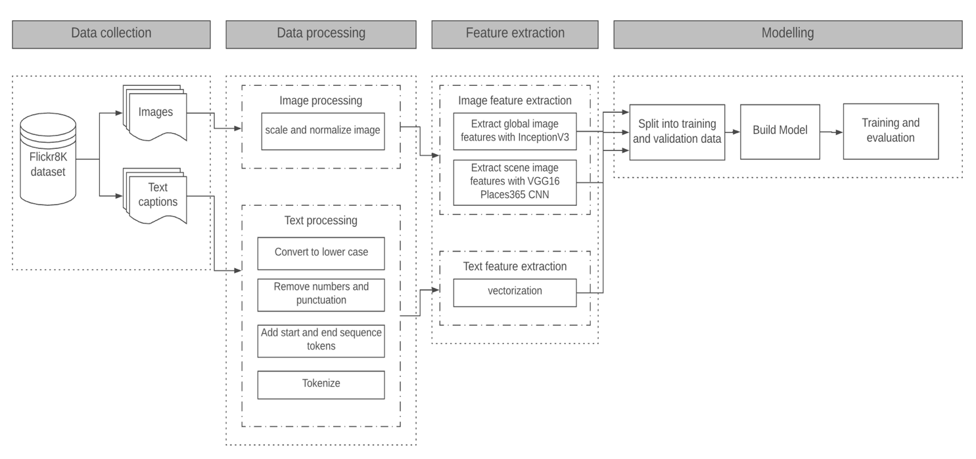
Figure 1. Research Methodology.
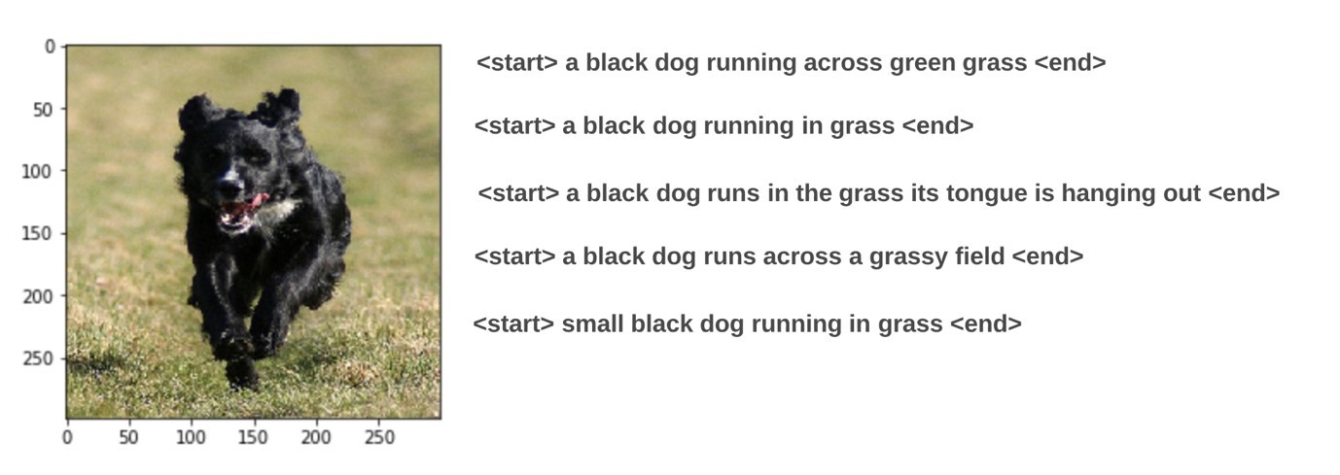
Figure 2. Sample normalized image and processed text descriptions.

In modelling, the recommended training and test data splits of 6000 for training and 1000 for development and validation are maintained. For building the model, the encoder-decoder model architecture is adopted as shown in Figure . The model has three separate inputs namely, the global image features, the scene image features and the reference text. Separate models are built for each of the inputs. The output of the global image feature input model and scene image feature input model is concatenated. The output of the concatenated model is then concatenated with the text input model and the output is sent to a fully connected Bi-LSTM layer and thereafter to a dense layer with softmax activation that predicts the word probabilities.
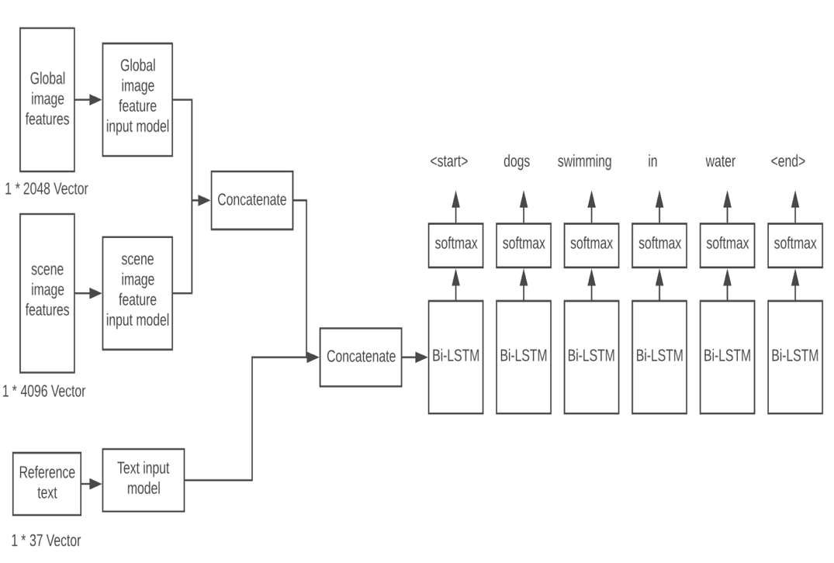
Figure 3. Modelling approach.
The model architecture showing the input layers, embedding layers, bidirectional LSTM layer and dense layer is shown in Figure . The first layer of the model takes the encoded image feature vectors. The input shape is dependent on resulting feature set from the image encoding model. For the global image features extracted using the Inception v3, the input shape was 2048. The scene features extracted using the VGG16 Places365 CNN had 4096 as feature dimensions and so the input shape for its model corresponded to 4096. This is followed by a dense layer that reduces the input dimension to match with the dimension of the text embeddings which is set at 300. A repeat vector layer is used to repeat the outputs from the dense layer for the maximum length of the text descriptions. The text input model is responsible for taking the processed text sequences. Its input shape is the maximum length of the vectorized sequences which is 37 as all the sentence descriptions are padded to this length. The embedding layer follows the input layer.

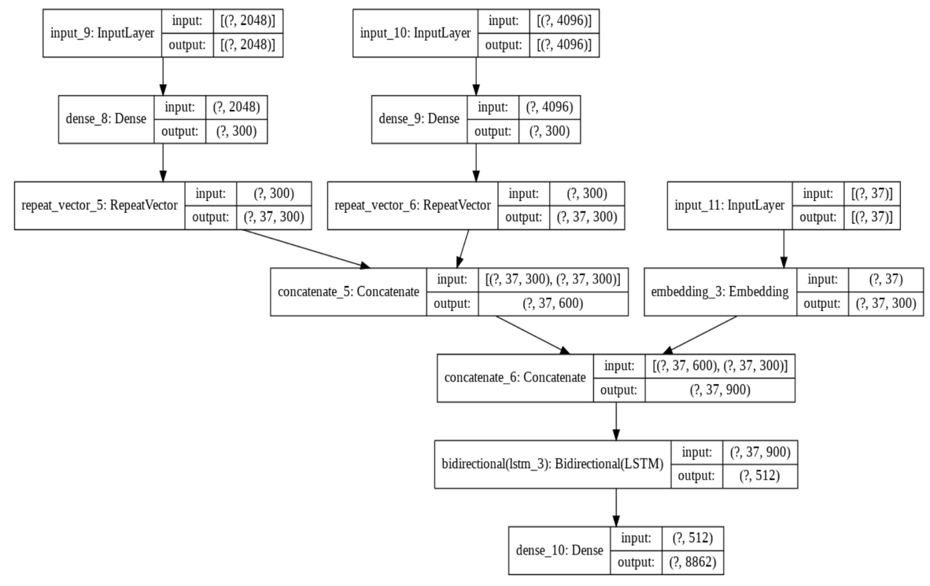
Figure 4. Model Architecture.
The embedding layer learns vector representations of each of the words in the text sequence in order to avoid matrix sparsity. Matrix sparsity can occur in other forms of word representations such as one hot encoding. An embedding dimension of 300 is used. This results in each word been represented by a 300-dimension vector in the output. The outputs from the image models and the text model are concatenated and passed to another bidirectional LSTM layer with 512 units. The final layer of the model is a dense layer with the vocabulary size of 8862 as the number of units. The softmax activation is used to predict the likelihood of each word to be the next in the sequence.
In training, 6000 images are used while 1000 images are used for validation and evaluation. For optimum use of computing resources, the data is progressively loaded using a data generator to deliver data in batches of 128 to the model to avoid loading all images into RAM at the same time. The model is compiled using ‘categorical_crossentropy’ as the loss and ‘RMSprop’ as the backpropagation optimizer. This is a popular choice in most of the observed literature due to its efficiency and faster convergence for neural language translation tasks^{[3],[11]}. To avoid overfitting, early stopping was used. The model was also checkpointed, and weights saved as validation loss decreased. Each epoch took approximately 11 minutes to run on Google Colab. To closely monitor overfitting, the model is evaluated using BLEU and ROUGE-L scores at 5, 10 and 15 epochs.

Results and discussion
The aim of the experiment is to investigate to what extent the use of scene features and bidirectional LSTMs can improve the correctness of automatically generated image captions. The approach is evaluated using BLEU and ROUGE -L scores as shown in Table 1. This research extends on the work of^{[7]}. Peng et al.^{[7]} employed a CNN-LSTM encoder decoder network to image captioning using scene features and a unidirectional LSTM. Peng et al.^{[7]} achieved a BLEU-1 score of 56, BLEU-2 score of 39, BLEU-3 score of 22.5, BLEU-4 score of 11.6 and ROUGE-L score of 41. This research proposes bidirectional LSTMs instead of a unidirectional LSTM in order to improve the semantic correctness of the generated captions especially for longer sequences. The results from the experiment at 5, 10 and 15 epochs for the BLEU and ROUGE-L scores are shown in Table .
Table 1. CNN-BiLSTM with image scene factors BLEU and ROUGE Scores
Epochs | BLEU-1 | BLEU-2 | BLEU-3 | BLEU-4 | ROUGE-L
5 | 55 | 34.9 | 24.8 | 13.1 | 27.9
10 | 53.4 | 33.7 | 24.0 | 12.4 | 27.4
15 | 46.8 | 29.5 | 20.9 | 10.8

It is observed that the performance of the model increased and peaked at 5 epochs. The result for BLEU-3 is 24.8 which indicates a better match for longer 3-gram word sequences. This is a 9% increase on the results reported by Peng et al.^{[7]}. The result for BLEU-4 is 13.1 which indicates a better match for longer 4-gram word sequences. This is a 12% increase on the results reported by^{[7]}. These results demonstrate that an encoder decoder CNN (Inception v3 and Places365 VGG16) model with bidirectional LSTM with scene features for image captioning is able to better match longer 3-gram and 4-gram word sequences. The results show promise that the use of scene features and bidirectional LSTMs can improve the correctness of automatically generated image captions especially for longer sequences.
The BLEU-1 score of 55, BLUE-2 score of 34.9 and ROUGE-L score of 27.9 are lower than the results reported by Peng et al.^{[7]}. These results indicate lower performance for shorter text sequences of 1-gram and 2-grams. The model also showed an increasing ability to overfit as performance started declining after 5 epochs from a BLEU-1 score of 55 to 53.4 at 10 epochs and a further 46.8 at 15 epochs.

Conclusion and future work
The aim of this research is to investigate to what extent a combination of image scene features and bidirectional LSTMs in an encoder-decoder architecture can improve the semantic meaning of automatically generated image captions. This research proposes a novel approach to generate sentences using visual scene information with a bidirectional LSTM decoder. The encoder is based on Inception v3 to extract the object features and Places365 to extract the scene features. The key finding from the evaluation of a CNN (Inception v3 and Places365 VGG16) model with bidirectional LSTM with scene features for image captioning is that there is a 9% increase in 3-gram and 12% increase in 4-gram word sequences compared to results reported by Peng et al.^{[7]}. This can be attributed to the ability of scene features to capture background context between the objects in the image and the use of bidirectional LSTMs as they are able to take into consideration past and future information during the word translation sequence. The results show promise that the use of bidirectional LSTMs can improve the correctness of automatically generated image captions especially for longer text sequences.
For future work, this research can be extended using the attention mechanism to bridge the gap between the image and text modalities by mapping the texts to specific image regions during word translation to lead to further increase in semantic correctness of the generated captions. Evaluation metrics able to compare reference and generated captions based on semantic meaning and not just based on n-gram matches can also be developed and adopted for more complete evaluation.

References
- Gupta, N. and Jalal, A.S. (2019) ‘Integration of textual cues for fine-grained image captioning using deep CNN and LSTM’, Neural Computing and Applications, 48(3), pp. 1-10. SpringerLink. doi: 10.1007/s00521-019-04515-z.
- Liu, X., Xu, Q. and Wang, N. (2019) ‘A survey on deep neural network-based image captioning’, The Visual Computer, 35(3), pp. 445-470. SpringerLink. doi: 10.1007/s00371018-1566-y.
- Vinyals, O., Toshev, A., Bengio, S. and Erhan, D. (2015) ‘Show and tell: A neural image caption generator’, in 2015 Proceedings of the IEEE conference on computer vision and pattern recognition. Boston, MA, USA, 7-12 June 2015, pp. 3156-3164, IEEE Xplore. doi: 10.1109/CVPR.2015.7298935.
- Chollet, F. (2017) Deep learning with python. 1st edn. Manning Publications Co.
- Zhang, X., He, S., Song, X., Lau, R.W., Jiao, J. and Ye, Q. (2019) ‘Image captioning via semantic element embedding’, Neurocomputing. [In press]. ScienceDirect. doi: 10.1016/j.neucom.2018.02.112.
- Khamparia, A., Pandey, B., Tiwari, S., Gupta, D., Khanna, A. and Rodrigues, J.J. (2019) ‘An Integrated Hybrid CNN–RNN Model for Visual Description and Generation of Captions’, Circuits, Systems, and Signal Processing, 39(2), pp.1-13. SpringerLink. doi: 10.1007/s00034019-01306-8.
- Peng, Y., Liu, X., Wang, W., Zhao, X. and Wei, M. (2019) ‘Image caption model of double LSTM with scene factors’, Image and Vision Computing, 86(3), pp. 38-44. ScienceDirect. doi: 10.1016/j.imavis.2019.03.003.
- Makav, B. and Kılıç, V. (2019), ‘Smartphone-based Image Captioning for Visually and Hearing Impaired’, in 2019 11th International Conference on Electrical and Electronics Engineering (ELECO). Bursa, Turkey, Turkey, 28-30 November 2019, pp. 950-953, IEEE Xplore. doi:10.23919/ELECO47770.2019.8990395.
- Kiros, R., Salakhutdinov, R. and Zemel, R.S. (2014) ‘Unifying visual-semantic embeddings with multimodal neural language models’, arXiv preprint arXiv:1411.2539, pp. 1-13. Available at: https://arxiv.org/pdf/1411.2539.pdf [Accessed: 3 Mar 2020]
- Xiao, F., Gong, X., Zhang, Y., Shen, Y., Li, J. and Gao, X. (2019) ‘DAA: Dual LSTMs with adaptive attention for image captioning’, Neurocomputing, 364(5), pp.322-329. ScienceDirect. doi: 10.1016/j.neucom.2019.06.085.
- Wang, C., Yang, H., Bartz, C. and Meinel, C. (2016) ‘Image captioning with deep bidirectional LSTMs’, in Proceedings of the 24th ACM international conference on Multimedia, New York, NY, USA, October 2016, pp. 988-997, ACM Digital Library. doi: 10.1145/2964284.2964299.
- He, X., Shi, B., Bai, X., Xia, G.S., Zhang, Z. and Dong, W. (2019) ‘Image caption generation with part of speech guidance’, Pattern Recognition Letters, 119(4), pp. 229-237. ScienceDirect. doi: 10.1016/j.patrec.2017.10.018.
- Dang, T.X., Oh, A., Na, I.S. and Kim, S.H. (2019), ‘The Role of Attention Mechanism and Multi-Feature in Image Captioning’, in Proceedings of the 3rd International Conference on Machine Learning and Soft Computing (ICMLSC). Da Lat, Vietnam, January 2019, pp. 170174, ACM Digital Library. doi: 10.1145/3310986.3311002.
- Zhang, X., Tang, X., Wang, X., Zhou, H. and Li, C. (2019) ‘Description generation for remote sensing images using attribute attention mechanism’, Remote Sensing, 11(6), p. 612630. Available at: https://www.mdpi.com/2072-4292/11/6/612 [Accessed: 18 Mar. 2020].
- Xiao, X., Wang, L., Ding, K., Xiang, S. and Pan, C. (2019) ‘Dense semantic embedding network for image captioning’, Pattern Recognition, 90, pp.285-296. ScienceDirect. doi: 10.1016/j.patcog.2019.01.028
- Ding, S., Qu, S., Xi, Y., Sangaiah, A.K. and Wan, S. (2019) ‘Image caption generation with high-level image features’, Pattern Recognition Letters, 123(2), pp. 89-95. ScienceDirect. doi: 10.1016/j.patrec.2019.03.021.
- Hossain, M.Z., Sohel, F., Shiratuddin, M.F. and Laga, H. (2018) ‘A comprehensive survey of deep learning for image captioning’, ACM Computing Surveys (CSUR), 51(6), pp.1-36. ACM Digital Library. doi: doi.org/10.1145/3295748.
- Hodosh, Micah, Peter Young, and Julia Hockenmaier. "Framing image description as a ranking task: Data, models and evaluation metrics." Journal of Artificial Intelligence Research 47 (2013): 853-899.
- Cao, D., Zhu, M. and Gao, L. (2019) ‘An image caption method based on object detection’, Multimedia Tools and Applications, 78(24), pp. 35329-35350. SpringerLink. doi: 10.1007/s11042-019-08116-9.
- Zhang, Y. and Zhang, J. (2019) ‘Application of Dual Attention Mechanism in Chinese Image Captioning’, Journal of Intelligent Learning Systems and Applications, 12(1), pp.14-29. Scientific Research Publishing. doi: 10.4236/jilsa.2020.121002.

